**SUSTAINABLE CITIES**

**Executive Summary**

This report contains the ongoing issues regarding the constructions of Dakar in Senegal. Furthermore, this chapter contains the issues of urbanisation that are effective to ensure the increase of the rate of housing in Dakar. Besides, this report contains issues regarding slums and housing in Dakar.

**Table of Contents**

1. Part A: Photo Essay on the Right to the City 4

1.1 Introduction 4

1.2 Main Body (Dakar, Senegal) 4

1.2.1 Physical Features Promoting Inclusiveness 4

1.2.2 Focus on One Special Group: Homelessness in Dakar, Senegal 6

1.2.3 Principle of Right to City 8

1.2.4 Author’s Point of View 9

1.3 Conclusion 10

2. Part B: CTA for cities' strategic planning 11

2.1 Introduction 11

2.2 Ongoing Issues 11

2.2.1 Urbanisation Issues 11

2.2.2 Slums and Housing 14

2.2.3 Three Key environmental issues 16

2.3 Conclusion 20

References 21

# 1. Part A: Photo Essay on the Right to the City

## 1.1 Introduction

Right to the city is defined as a multi-dimensional operation of utilising social mobilisation and community-led action to transform and reclaim cities as equitable and democratic. The right to the city is an effective process that helps to enhance the experience of the citizens regarding the construction and environmental factors of the city. the Government of Senegal needs to identify the economical, political, educational, and ecological state of Dakar to ensure the success of the city. the city right is the factor that is helpful to maintain the city environment that is essential to enhance the health factors of the citizens. Besides, the right to the city is a process of maintaining a sustainable city that is essential to enhance the health factors and economic factors of the citizens. The usage of city rights is helpful to enhance the transformation of cities such as Dakar.

## 1.2 Main Body (Dakar, Senegal)

### 1.2.1 Physical Features Promoting Inclusiveness

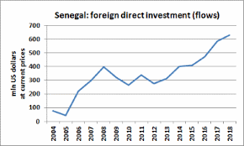

**Figure 1: Shaping Future of Mobility in Senegal**

(Source: Westafrica.com.ua, 2023)

The physical features of Dakar promote the mobility of Senegal, and the physical features also help to make suitable access to services in Senegal. The mobility service revenue has increased for more than 73.7 percent in Senegal due to the demand of mobility in cities like Dakar (Statista.com, 2023). The transportation of Dakar has become easier due to the presence of bus companies from every city of Senegal that reach Dakar. The bus and mini bus services of Dakar is one of the most popular forms of public transportation as it provides easy transportation. It has been identified that mobility of this city has been a positive aspect for this city assisting it in improving success and effectiveness for individuals residing within this place. According to the views of Rossetti *et al.* (2020), accessibility of public transportation refers to the presence of public transportation to travel and transport. The maximum places of Dakar is the capital and most largest city of Senegal that have helped to enhance the transportation system of Dakar.

Dakar has urban problems caused by rapid growth of populations and illegal housing that have been encouraged to enhance the transportation system of the city. Besides, the improvised transportation system is helpful for Dakar to enhance the economic growth of the country as the capital of Senegal. The geographical features of Dakar are effective to promote transportation due to the rolling plain lands of the city. According to Lesteven *et al.* (2022), the multiple types of public services such as healthcare services, fire extinguisher services and delivery services in Dakar play a vital role to improve the transportation services. The usage of easy and fast transportation is essential to enhance the public service in Dakar. The public services of Dakar are developed in the urban area of Dakar but the undeveloped physical features in the rural area of Dakar cannot access the public services in Senegal.

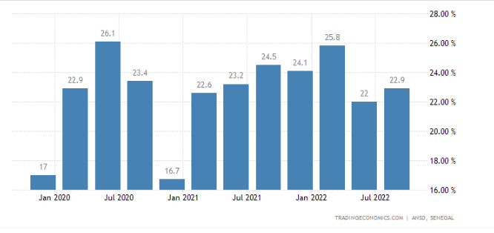

**Figure 2: Unemployment rate of Senegal**

(Source: Tradingeconomics.com, 2023)

The urban area of Dakar can access the different types of service on a daily basis but the rural area of Dakar always faces natural calamities such as floods and coastal erosion. According to the views of Ba *et al.* (2019), the rural areas of Dakar get affected due to natural calamities as these areas have issues regarding transportation systems. The transportation issues create barriers to accessing health and other public services in the rural areas of Dakar. The physical features of Dakar, Senegal are suitable for mobility and service access in the urban area of Dakar (Britannica.com, 2023). It has been identified that the poor condition of living in Dakar, Senegal has been restricting people in improving health conditions affecting progress and sustainable development.

### 1.2.2 Focus on One Special Group: Homelessness in Dakar, Senegal

The identified big issue in Senegal, mainly in Dakar is the increase of population that have created issues regarding the maintenance of the city. It is estimated that nearly 14 million residents of Dakar live in the crowded slums of Senegal and about 53.260% people have no kind of basic shelter to stay (Africapolis.org, 2023). It is prominent that a huge number of people of Dakar, Senegal are affected due to the homelessness. Roughly 31000 cases of casualties have been reported in Dakar due to natural casualties such as flood and soil erosion (Statista.com, 2023). The homeless population of Senegal is suffering from erratic unemployment and excessive loss due to natural calamities. The average rate of death of homeless people in Dakar is 100,000 among the population of homeless people (Statista.com, 2023). Therefore, the huge population in Dakar is the main reason behind the huge rate of homelessness in Senegal. The homelessness of Dakar causes issues regarding the maintenance of the city as the increasing rate of homeless people include issues regarding the damage of government properties.

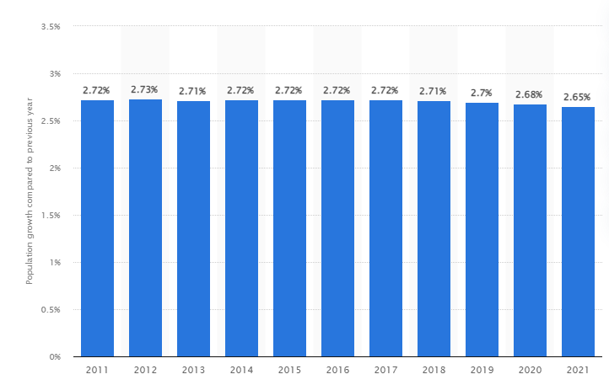

**Figure 3: Population growth in Dakar**

(Source: Statista.com, 2023)

The Senegal government is not able to provide the proper security, employment, education, food, and minimum shelter to survive. Hence, it can be stated that homelessness is a crucial issue in Dakar. Approximately 20.74% Income insecurity is a huge problem that has increased homeless people in Dakar. As stated by Teye and Nikoi (2022), a lot of people in Dakar lost their shelter because of floods and soil erosion. Hence, the shot of income becomes infrequent because of their sudden homelessness. Many corporate companies in Dakar cannot provide the proper job to the homeless people, hence the homeless individuals become incapable of income. On the other hand, according to Singer and Rylko-Bauer (2021), the other problem faced by homeless people of Senegal is healthcare insecurity. Many homeless individuals have no proper income and without money, it is difficult to get healthcare services in Dakar. Dakar is not that economically developed, hence, the government of Senegal cannot provide free healthcare services to the homeless people in Dakar Lahti (2019). Hence, Dakar needs to access the right to the city and it can help to develop the economic condition of Senegal. The homelessness in Senegal include issues regarding the healthcare of street children due to lack of health security and maintenance of hygiene (Alegbeleye and Mohammed). It also happens because of homelessness in Senegal mainly in Dakar and the homeless people have no permanent income source. Hence, the homeless people of Dakar cannot afford food that increases the rate of malnutrition and health issues among the residents Raimi *et al.* (2021). Homelessness puts individuals in Dakar at a more increased risk for poor health, victimisation, depression, and loneliness, which can result in chemical dependence, corruption, and create other issues.

These are extremely harmful to the society of Dakar and they hamper the social development of Senegal. Moreover, as stated by Kaushik (2022), every resident of the nation needs basic educational knowledge, which is not possible for the homeless people of Dakar. This also decreases the educational development of Senegal. It can be stated that the huge number of homeless people in Senegal have decreased the healthcare development, educational development, and economical development of Senegal.

### 1.2.3 Principle of Right to City

Right to the city of Dakar needs to follow some important principles which have to be maintained by the city and its residents. The most important principles of the right to the city are, resourceful, accessible, shared, secure, and desirable. Dakar needs to be resourceful because a resourceful city can sustain the economical and ecological state of the city. The city needs to be self-sufficient and circular with food, proper water, education, and employment. These resources can help to maintain ecological and economical sustainability in the city (Kitchin *et al*. 2019). On the other hand, Dakar needs to be an accessible city that can be built for inclusion and diversity. This city needs to maintain equality of age, religion, ability, gender identity, sexual orientation, financial stability, political views, and ethnicity. Thus, people in Dakar, Senegal have developed a democratic atmosphere that has been assisting them in improving sustainable places with increased equal rights. As stated by Izadi *et al*. (2021), this equality factor can secure equal and fair access to urban employment, amenities, healthcare, nature, services, culture, heritage, leisure, business, sport, and education. These all factors can help to change Dakar into an ideal city in Senegal.

Dakar needs to focus on the share principle for the development of the city to ensure the growth of the economic structure. Mainly, this city needs to encourage collaboration, community, and togetherness in society (Marshall *et al*. 2021). Encouraging collaboration can assist Dakar, Senegal in improving sustenance and harmony that can assist this place in enhancing prosperity and equality accordingly. Togetherness and collaboration can help to develop social relations through public spaces, transportation, co-living and co-working spaces, and shared facilities (Floridi and Cowls 2022). It encourages pooling intangible sources also, like shared mobility technologies, initiatives that promote significant social relationships, and skill-share. These all are important for the modification of the city of Dakar as these factors are essential to provide structured improvisation for the city. On the other hand, the other important principle of the right to the city is the maintenance of security in the city. Dakar needs to focus on the security issue and take an initiative to decrease the violence rate of Dakar. The rate of criminal activities and road traffic accidents are the major issues of Dakar due to the increase of homeless people on the roads. Hence, it can be stated that Dakar has critical issues related to security and this city needs to develop security services throughout the city.

Dakar needs to focus on the basic development of rural areas of the city because rural residents of Dakar suffer from homelessness, unemployment, fewer education facilities, and mostly insecure food problems. Most of the parts of Dakar are considered rural areas; hence, this rural area needs to be developed for the entire development of this city. According to Peralta Quiros *et al.* (2019), Dakar needs to concentrate on the employment matter because a proper employment rate can help a city to be an economically successful city. It can be also stated as an important principle of the right to the city process of Dakar.

### 1.2.4 Author’s Point of View

Jane Jacobs acknowledged that cities were constructed significantly by their diversity. Containing buildings with various goals promotes enthusiastic activity throughout the city. As per Jacobs, proper use of retails, availability of food, high employment rate, and proper education can make a city ideal. She stated for the city of Dakar that this city needs to increase the development rate in different types of parts because Dakar is a less average developed country in Senegal. This city needs to focus on education access in the rural areas because the residents of rural areas suffer from homelessness, hence, they do not have basic education. Similarly, as stated by Sarker and Pervin (2020), education is the most effective base of any successful city, hence, Dakar needs to develop its educational condition. On the other hand, Jane Jacobs shed light on the employment issue and safety issues of Dakar. According to him, the unemployment rate in the rural areas of Dakar is extremely high, hence this issue increases the economic challenge in Dakar. On the contrary, as stated by Warner (2022) the government, Dakar needs to give the proper shelter and food to the homeless residents of Dakar. This initiative can solve every issue related to homelessness in Dakar and automatically makes a positive impact on the growth of entire Senegal.

The most important theory of Jane Jacobs is that the ideal city depends on the healthiness of the city. Hence, according to Jacobs’s statement Dakar needs to focus on the development of the healthcare system and the healthcare system needs to provide proper health services to the residents of urban as well as rural areas. A successful healthcare system can help to develop a successful and healthy city. Hence, it can be stated that the point of view of Jacobs is important for the right to the city of Dakar.

## 1.3 Conclusion

It can be concluded that the physical factors or geographical factors of Dakar promote access to service and mobility in the city. The proper geographical division is the mobility access in the urban areas of Dakar. On the other hand, the residents of the urban areas of this city can easily access healthcare services. The public service, such as electric and water supply service, security service, and fire department service are properly provided by the government of this city. This study also focused on the homelessness issue of this city. The residents of the rural area of Dakar suffer from homelessness and maximum rural people do not have basic shelter to stay. Homelessness creates some other problems in this city, such as unemployment, less education, food insecurity, and health service insecurity. This study highlighted the important principles of rights to the city of Dakar. This study analyses the point of view of Jane Jacobs on the right to the city process of Dakar.

# 2. Part B: CTA for cities' strategic planning

## 2.1 Introduction

Various issues in any city have a negative impact such as unemployment, poor health, enhancement of pollution, traffic congestion and water and sanitation problems. This paper focuses on three issues such as urbanisation issues, slums and housing issues and three environmental issues in the city Dakar, Senegal. These issues can increase urban crime and spreading of disease. Moreover, these issues can also increase carbon emission into the atmosphere and loss of biodiversity into this city.

## 2.2 Ongoing Issues

### 2.2.1 Urbanisation Issues

***Rising prices of real estate***

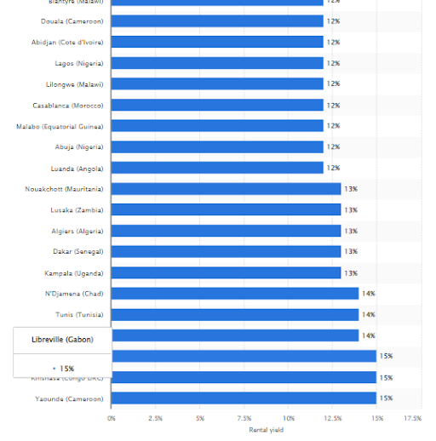

**Figure 4: Land/Flat priced in Dakar**

(Source: Statista.com, 2023)

The real estate prices in Dakar have been constantly growing which has led to increased slums and homeless people in the city. However, Dakar has been identified to be the fastest-growing African city with a population of 3,429,536 in 2023 (Worldpopulationreview.com, 2023). In recent years, Dakar is facing significant issues of urbanisation influenced majorly by the rural-urban migration factor that has led to an increasingly urban population. According to Faye and Du (2021), land prices in Dakar have dramatically grown in the last five years due to growing urbanisation. In this context, rising real estate prices have been evaluated as a critical issue of urbanisation in Dakar, Senegal. According to a study by IPD, land prices in Dakar surged to 13% and more than twenty-seven-fold in the past two decades Pouye *et al.* (2022). Therefore, showcasing that real estate prices have significantly increased in the last few years causing a critical urbanisation issue in the city. Thus, despite having an opportunity of living in an urbanised city, high cost of living has been resisting the people of Dakar in Senegal facing a significant economic crisis.

***Lack of city government policies***

Urban governance policies in Dakar are constantly striving to meet resources and requirements of increasing urban migrants. According to Meyer and Auriacombe (2019), driving market changes, and security challenges because of migration are key factors that have boosted the issue of urban governance policy lack in Dakar. Low maintenance governance policies within Dakar, Senegal has been restricting citizens in abiding practical laws and sustainability while receding within this place. Moreover, significant qualitative variations between urbanisation methods of developed and developing countries are a key factor influencing lack of governance policies in Dakar. Similarly, as stated by Akanle and Omobowale (2022), the problems encountered in policy of developed countries are evidently different from developing countries. The government does not emphasise urbanisation and investment in infrastructural development. In this context, Dakar City Corporation Ordinance is the only governance policy for urban regulation in Dakar Carré *et al.* (2020). The policy regulated urbanisation needs and procedures within the city of Dakar. Therefore, a significant lack of government policy exists in Dakar leading to imposition of critical urbanisation issues.

***Ineffective community participation***

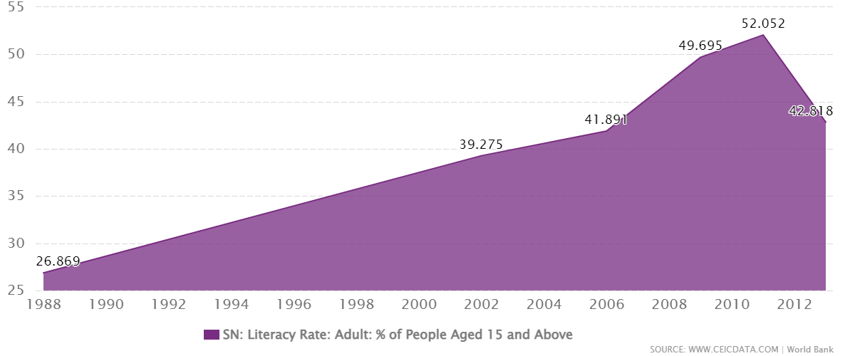

**Figure 5: Literacy rate in Dakar**

(Source: Ceicdata.com, 2023)

The older generation population in Dakar, Senegal resist urbanisation changes and modernisation of infrastructure or buildings. Effective urbanisation essentially requires community participation to support business market growth and infrastructural development. However, due to increased cost of living, people of communities in Dakar have been resisting the approach of progress and prosperity affecting financial and economic development. Ineffective community participation imposes a limitation on collaborative government decisions on modernization of city infrastructure and buildings. According to Diouf *et al.* (2019), urbanisation in Dakar is restricted significantly due to a lack of neighbours and local community. Lack of appropriate educational institutions and education is a core reason behind ineffective participation from community in Dakar. The literacy rate in Dakar is approximately 52% which is significantly low compared to average global literacy rate of 92% (Ceicdata.com, 2023). Hence, indicating that a lower literacy rate imposes a critical restriction of ineffective community engagement and participation in urbanisation of Dakar imposing urbanisation issues.

***Un-skilled institutional management***

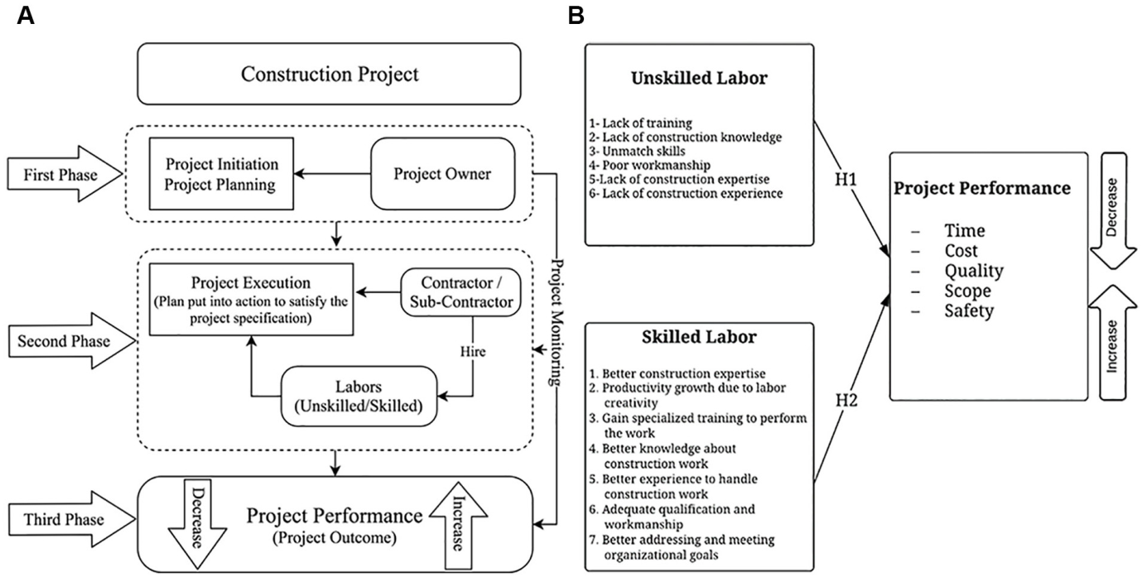

**Figure 6: Unskilled institutional management**

(Source: Influenced by Diouf *et al.* 2019)

Unskilled institutional management is an issue regarding urbanisation as it creates barriers regarding the work process due to lack of effective participation. As commented by Oliinyk *et al.* (2021), the lack of skilled management creates issues regarding the work process as it creates barriers to enhance the quality of the work process. The urbanisation in Dakar requires a skilled management process to mitigate the issues regarding the increasing numbers of slums and squatters. Furthermore, at least 80% of people living in Dakar are unable to own flats and remain tenants for years due to lack of effective management process for urbanisation (Statista.com, 2023). Therefore, the unskilled institutional management impacts the process of urbanisation that is harmful for the citizens of Dakar.

### 2.2.2 Slums and Housing

***Scarcity of lands***

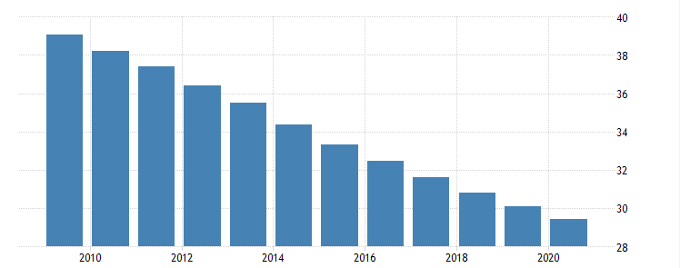

**Figure 7: High employment rate for agriculture in Senegal**

(Source: Tradingeconomics.com, 2023)

The slums and housing in Dakar faces issues regarding the scarcity of lands as it creates issues regarding the construction process. In 2020 Senegal has reported a downfall of 29.43% in the employment rate in agricultural industry (Tradingeconomics.com, 2023). The sacristy of lands is an impact due to the increase of population, poor land usage and insecurity regarding land tenure. Furthermore, the scarcity of lands in Dakar, Senegal has created issues regarding the housing in this place as it impacts the construction due to the lack of areas. According to the views of Benegiamo (2020) increased land scarcity in Dakar, Senegal has reduced a significant low access to lands impacting the agricultural industry significantly. Moreover, the scarcity of lands increases the numbers of slums in Dakar, Senegal that impact the cultural aspect of the city significantly. The intensified agricultural practices are also an important reason for the scarcity of lands. Scarcity of lands is responsible for the increase of slum areas in Dakar, Senegal which can impact the citizen's life by creating unsanitary living conditions.

***High cost of construction***

The high cost of construction is an important reason behind the increase of slum areas in Dakar, Senegal as it has been affecting the construction process within the city. As commented by González-Sánchez *et al.* (2020), the high cost of construction in the framing and developing construction by managing the resources is essential. Due to this major aspect, people in this place have been unable to engage with the agricultural industry resisting success and effectiveness. For this reason, in Senegal, the construction industry has been impacted due to the lack of human resource and financial engagement that has been impacting the sustainability approach of the cities within this place. In Dakar, Senegal the real estate price has been increasingly high considering the demand for posh locations among the potential development which impacts on the performance. According to the views of Sanni-Anibire *et al.* (2020), accidents and constructional hazards impact on the development and growth of the industry. Lack of emergency management has been restricting healthcare workers in providing proper guidance towards needful people affecting sustainability and success at a significant rate. High cost of land pieces also impacts on understanding in the construction industry. The high cost of construction has created issues regarding the housing in Dakar, Senegal as it has been affecting the cost of living within this place creating a major challenge for civilians.

### 2.2.3 Three Key environmental issues

Three major environmental issues which Dakar, Senegal is facing are climate change, mismanagement of solid wastes and air pollution. As per the view of Hammad *et al.* (2019), environmental issues have a negative effect on a city and on the health condition of its people. Climate change issues in Dakar have failed the humidity level, increased temperature and also decreased summer rainfall that have affected the health conditions of the citizens in Dakar city. Dakar has experienced about 0.5 degree centigrade of temperature rising in 2019 and rainfall has decreased by 60 millimetres in 2019 due to excessive climate change (Statista.com, 2023). Due to these major climate issues, people in Dakar have been facing complexities in maintaining physical, emotional and psychological health conditions.

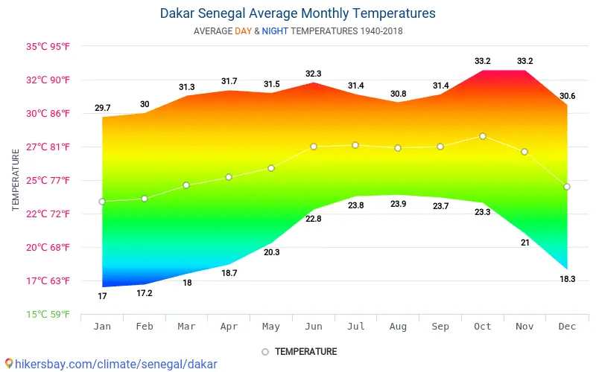

**Figure 8: Changes in temperature in Dakar**

(Source: Statista.com, 2023)

Solid waste management is another main environmental issue in Dakar and thus reduced sustainability of the environment. About 5000 wastes have been generated in Dakar on a daily basis and only 37% of these are managed in appropriate manner (Global-recycling.info, 2023). This environmental issue in Dakar increases land population and loss of habitat in this city.

Dakar is exposed to high levels of air pollution and this has increased breathing difficulties and risk of infection among citizens. The real time air quality in Dakar is about 140 AQI which is very poor (Statista.com, 2023). Poor air quality in Dakar has increased the rate of risk of death and disability in this city. Air pollution in Dakar has increased the risk of death and disability in Dakar by about 17.6% in 2022 (Statista.com, 2023). Dakar has to focus on addressing this issue to increase sustainability.

Dakar has focused on the level of carbon emission into the atmosphere to address climate change environmental issues in this city. Carbon dioxide emission into the atmosphere in Dakar is about 0.5 metric tons per capita in 2020 (Ourworldindata.org, 2023). Moreover, Dakar has focused on daily waste transportation to landfill to address issues in solid waste management in this city. Dakar has focused on adoption of more CNG vehicles and green technologies in the vehicles for addressing air pollution in this city.

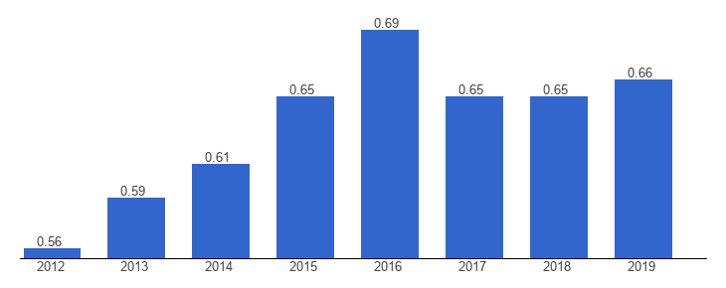

**Figure 9: Carbon dioxide emission in Dakar, Senegal**

(Source: Ourworldindata.org, 2023)

Senegal has adopted various innovative policies in order to reduce climate change and environmental issues. Senegal has focused on adoption of a policy in which this city has invested in climate resilient and disaster preparedness (Ourworldindata.org, 2023). This helps Dakar also to combat climate change and environmental issues. Senegal has adopted effective legislation that is effective to enhance the usage of suitable powers to ensure sustainability of nature that is effective to ensure the success of the city. This innovative policy of Senegal has helped Dakar to manage its climate change environmental issue. This is effective for Dakar as this helps in building a protection against climate change and to increase sustainability of the environment.

Dakar has also focused on innovative policies in order to manage solid wastes in an effective manner. Dakar City Corporation has focused on adaptation of an effective waste management system in which this city focuses on door to door community based waste connotation from households (Dieng *et al.* 2022). Moreover, DCC has also focused on an informal waste recycling system to recycle solid wastes. This initiative is effective for Dakar as this helps in management of solid wastes in an appropriate manner. Solid wastes are connected in Dakar in a non segregated way and collected wastes are then disposed of in the landfill. This innovative initiative has been assisting people in Dakar city in combating issues of pollution at a significant rate. Thus, by attaining a healthy living condition, people in this place has been able to improve their health conditions at a significant rate.

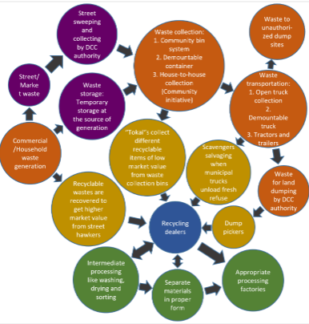

**Figure 10: Waste management framework in Dakar**

(Source: Ourworldindata.org, 2023)

Senegal has also focused on policies to mitigate air pollution issues in the city of Dakar. Senegal has adopted a “clean air and sustainable environment project” to improve air quality in Dakar and also in Senegal (Bassi *et al.* 2022). This is an effective approach by Senegal as this helps to increase use of public transport and also helps to motivate the use of more CNG in vehicles. Moreover, this initiative also helps in utilisation of clean burning biomass stoves for cooking to reduce air pollution and to improve air quality in Dakar.

Dakar can focus on use of more renewable energy as this is a long term cost saving approach and helps in reduction of climate change environmental issues. Moreover, Dakar might deal with electrification of transportation as this might be helpful for this city to reduce carbon emission into the atmosphere. Dakar should focus on adoption of sustainable plastic free options to manage solid wastes in an appropriate manner. This might be effective for Dakar as these can be easily disposed of and reduce landfill pollution. Dakar can focus on the use of non toxic or less toxic chemicals in vehicles to mitigate the environmental issue of air pollution. This might be helpful for Dakar in reduction of more chemicals into the atmosphere and improving air quality.

## 2.3 Conclusion

It can be concluded that slums in Dakar, Senegal have been facing significant residential issues. In addition, it has also been identified that a poor living atmosphere has been reducing health conditions of individuals living within this place. Furthermore, Dakar has also been facing a significant issue of urbanisation due to which cost of living has been affecting economic aspects within this place. ineffectiveness of governing policies within this place has been affecting growth and development reducing the participation rate of civilians. environmental issues and deteriorating health conditions of individuals has been resisting growth of this place at a significant rate. It has been identified that carbon emission and burning biomass has been identified as two major significant issues restricting health conditions of people within this place. Thus, it can be stated that because of these issues this city of Senegal has been facing a significant crisis in enhancing growth and development effectively.

# References

Floridi, L. and Cowls, J., (2022). A unified framework of five principles for AI in society. *Machine learning and the city: Applications in architecture and urban design,* pp.535-545.

González-Sánchez, R., Settembre-Blundo, D., Ferrari, A.M. and García-Muiña, F.E., (2020). Main dimensions in the building of the circular supply chain: A literature review. *Sustainability*, *12*(6), p.2459.

Kitchin, R., Cardullo, P. and Di Feliciantonio, C., (2019). Citizenship, justice, and the right to the smart city. In *The right to the smart city*. Emerald Publishing Limited.

Marshall, C.A., Cooke, A., Gewurtz, R., Barbic, S., Roy, L., Ross, C., Becker, A., Lysaght, R. and Kirsh, B., 2021. Bridging the transition from homelessness: Developing an occupational therapy framework. *Scandinavian Journal of Occupational Therapy*, pp.1-17.

Sanni-Anibire, M.O., Mahmoud, A.S., Hassanain, M.A. and Salami, B.A., (2020). A risk assessment approach for enhancing construction safety performance. *Safety science*, *121*, pp.15-29.

Westafrica.com.ua, (2023). Market West Africa. Available at: http://westafrica.com.ua/en/senegal_investments_engl[Accessed on: 16.04.2023]

Statista.com, (2023). Revenue growth of segments of the mobility services market in Africa from 2018 to 2026. Available at: https://www.statista.com/forecasts/1182770/revenue-growth-mobility-services-africa [Accessed on: 16.04.2023]

Rossetti, S., Tiboni, M., Vetturi, D., Zazzi, M. and Caselli, B., (2020). Measuring pedestrian accessibility to public transport in urban areas: A GIS-based discretisation approach. *Eur. Transp. Trasp. Eur*, *76*(2).

Lesteven, G., Cissokho, D., Pochet, P., Diongue, M. and Sakho, P., (2022). Daily Mobility in Urban Peripheries: The Role of Clandestine Taxis in Dakar, Senegal. *Sustainability*, *14*(11), p.6769.

Tradingeconomics.com, (2023). Senegal Unemployment Rate. Available at: https://tradingeconomics.com/senegal/unemployment-rate[Accessed on: 16.04.2023]

Ba, A.N., Verdin, A., Cazier, F., Garcon, G., Thomas, J., Cabral, M., Dewaele, D., Genevray, P., Garat, A., Allorge, D. and Diouf, A., (2019). Individual exposure level following indoor and outdoor air pollution exposure in Dakar (Senegal). *Environmental Pollution*, *248*, pp.397-407.

Britannica.com, (2023). Dakar national capital, Senegal Available at:https://www.britannica.com/place/Dakar[Accessed on: 16.04.2023]

Africapolis.org, (2023). © Mapbox © OpenStreetMap Improve this map

Senegal. Available at: https://africapolis.org/en/country-report/Senegal[Accessed on: 16.04.2023]

Statista.com, (2023). Number of deaths from natural disaster events worldwide from 2000 to 2022. Available at: https://www.statista.com/statistics/510952/number-of-deaths-from-natural-disasters-globally/ [Accessed on: 16.04.2023]

Statista.com, (2023). Homeless death rate 9 times higher in the most poverty-hit areas. Available at: https://www.statista.com/chart/17149/homeless-death-rate-uk-deprivation/[Accessed on: 16.04.2023]

Teye, J.K. and Nikoi, E.G., (2022). Climate-induced migration in West Africa. In *Migration in West Africa: IMISCOE Regional Reader* (pp. 79-105). Cham: Springer International Publishing.

Singer, M. and Rylko-Bauer, B., (2021). The syndemics and structural violence of the COVID pandemic: anthropological insights on a crisis. *Open Anthropological Research*, *1*(1), pp.7-32.

Lahti, S.E., (2019). A tale of two NGO discourses: NGO stories of suffering Qur’anic school children in Senegal. *Disadvantaged childhoods and humanitarian intervention: processes of affective commodification and objectification*, pp.113-134.

Alegbeleye, B.J. and Mohammed, R.K., (2020). Challenges of healthcare delivery in the context of COVID-19 pandemic in Sub-Saharan Africa. *Iberoamerican Journal of Medicine*, *2*(2), pp.100-109.

Raimi, M.O., Vivien, O.T. and Oluwatoyin, O.A., (2021). Creating the healthiest nation: Climate change and environmental health impacts in Nigeria: A narrative review. *Morufu Olalekan Raimi, Tonye Vivien Odubo & Adedoyin Oluwatoyin Omidiji (2021) Creating the Healthiest Nation: Climate Change and Environmental Health Impacts in Nigeria: A Narrative Review. Scholink Sustainability in Environment. ISSN*.

Kaushik, B., (2022). Right to Education of Child Beggars in India: A Critical Analysis. *Specialusis Ugdymas*, *1*(43), pp.8336-8351.

Peralta Quiros, T., Kerzhner, T. and Avner, P., (2019). Exploring Accessibility to Employment Opportunities in African Cities: A First Benchmark. *World Bank Policy Research Working Paper*, (8971).

Warner, T., (2022). Enduring Epidemic: Aesthetic Aftershocks of the 1914 Plague and the Segregation of Dakar. *Cambridge Journal of Postcolonial Literary Inquiry*, *9*(3), pp.293-316.

Statista.com, (2023). Rental yields for prime industrial real estate in selected cities in Africa in 2020. Available at: https://www.statista.com/statistics/1016921/rental-yields-for-prime-industrial-real-estate-africa-by-city/[Accessed on: 16.04.2023]

Worldpopulationreview.com, (2023). Dakar Population 2023. Available at: https://worldpopulationreview.com/world-cities/dakar-population [Accessed on: 16.04.2023]

Faye, B. and Du, G., (2021). Agricultural Land Transition in the “Groundnut Basin” of Senegal: 2009 to 2018. *Land*, *10*(10), p.996.

Pouye, I., Adjoussi, D.P., Ndione, J.A., Sall, A., Adjaho, K.D. and Gomez, M.L.A., (2022). Coastline Dynamics Analysis in Dakar Region, Senegal from 1990 to 2040.

Meyer, N. and Auriacombe, C., (2019). Good urban governance and city resilience: An afrocentric approach to sustainable development. *Sustainability*, *11*(19), p.5514.

Akanle, O. and Omobowale, A.O., (2022). Contemporary Issues in Public Policy. In *Public Policy and Research in Africa* (pp. 123-158). Cham: Springer International Publishing.

Carré, F., Horn, P. and Bonner, C., (2020). Collective bargaining by informal workers in the Global South: Where and how it takes place. In *Research handbook on development and the informal economy* (pp. 285-316). Edward Elgar Publishing.

Ceicdata.com, (2023). Senegal SN: Literacy Rate: Adult: % of People Aged 15 and Above. Available at: https://www.ceicdata.com/en/senegal/education-statistics/sn-literacy-rate-adult--of-people-aged-15-and-above [Accessed on: 16.04.2023]

Diouf, R.N., Dacosta, H. and Faye, T., (2019). URBANISATION ET INONDATION DANS LE BASSIN VERSANT DE LA GRANDE NIAYE DE PIKINE (DAKAR-SÉNÉGAL). *Akofena-Revue scientifique des Sciences du Langage, Lettres, Langues & Communication,*, *1*(01), pp.89-102.

Oliinyk, O., Bilan, Y., Mishchuk, H., Akimov, O. and Vasa, L., (2021). The impact of migration of highly skilled workers on the country's competitiveness and economic growth. *Montenegrin Journal of Economics*.

Statista.com, (2023). Senegal - Statistics & Facts Available at: https://www.statista.com/topics/4619/senegal/[Accessed on: 16.04.2023]

Hammad, H.M., Ashraf, M., Abbas, F., Bakhat, H.F., Qaisrani, S.A., Mubeen, M., Fahad, S. and Awais, M., (2019). Environmental factors affecting the frequency of road traffic accidents: a case study of sub-urban area of Pakistan. *Environmental Science and Pollution Research*, *26*, pp.11674-11685.

Statista.com, (2023). Climate and Weather Available at: https://www.statista.com/markets/408/topic/2445/climate-and-weather/[Accessed on: 16.04.2023]

Global-recycling.info, (2023). Senegal’s Waste Management: The Privat Sector Is Wanted. Available at: https://global-recycling.info/archives/6565 [Accessed on: 16.04.2023]

Statista.com, (2023). Environment - Senegal. Available at: https://www.statista.com/outlook/co/environment/senegal [Accessed on: 16.04.2023]

Ourworldindata.org, (2023). Senegal: CO2 Country Profile Available at: https://ourworldindata.org/co2/country/senegal [Accessed on: 16.04.2023]

Dieng, C., Mberu, B., Dimbuene, Z.T., Faye, C., Amugsi, D. and Aboderin, I., (2022). Biomedical waste management in Dakar, Senegal: Legal framework, health and environment issues; policy and program options. *Cities & Health*, *6*(1), pp.208-222.

Bassi, A.M., Pallaske, G., Niño, N. and Casier, L., (2022). Does Sustainable Transport Deliver Societal Value? Exploring Concepts, Methods, and Impacts with Case Studies. Future Transportation, 2(1), pp.115-134.

Tradingeconomics.com, (2023). Senegal - Employment In Agriculture (% Of Total Employment Available at: https://tradingeconomics.com/senegal/employment-in-agriculture-percent-of-total-employment-wb-data.html [Accessed on: 16.04.2023]

Benegiamo, M., (2020). Extractivism, exclusion and conflicts in Senegal’s agro-industrial transformation. Review of African Political Economy, 47(166), pp.522-544.